**Visvesvaraya Technological University,**

**Jnana Sangama, Belagavi – 590 018**

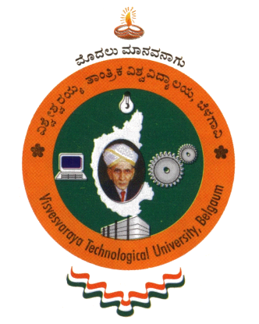

**KLS Vishwanathrao Deshpande Institute of Technology,**

**Haliyal – 581 329**

**(Accredited by NAAC with “A” Grade)**

**Department of Computer Science and Engineering**

**CERTIFICATE**

Certified that the Project Work entitled **“ AI-Driven Dyslexia detection and personalized learning aid for dyslexic patients ”**carried out by

**Mr. Manoj F Patil (2VD21CS023)**

**Mr. Naveenraj R Nikkammanavar (2VD21CS028)**

**Mr. Sanket N Shinde (2VD21CS045)**

**Mr. Vilas N Bhat (2VD21CS058)**

are bonafide students of KLS VDIT, Haliyal, in partial fulfillment for the award of Bachelor of Engineering in Computer Science and Engineering, of the Visvesvaraya Technological University, Belagavi during the year 2024-2025. It is certified that all corrections / suggestions indicated for Internal Assessment have been incorporated in the Report deposited in the Departmental Library. The Project report has been approved as it satisfies the academic requirements in respect of Project Work prescribed for the said Degree.

|  |  |  |
| --- | --- | --- |
| **GUIDE**  **Dr . Naveenkumar T Rudrappa** | **HOD**  **Dr. Venkatesh S** | **PRINCIPAL**  **Dr. V. A. Kulkarni** |

**Name of the Examiners Signature with Date**

**1. _______________________ _______________**

**2. _______________________ _______________**